Comparison of Quick Sort and Merge Sort:

1. **Quick Sort**: Quick Sort is faster

* Quick sort algorithm follows the divide and conquer approach to sort an array of elements.
* First it will choose the pivot element, pivot element is selected by the algorithm to proceed with the sorting.
* It will split the array elements into two sub-arrays; one is less than the pivot element and greater than pivot element.
* It will recursively apply the quick sort to the two sub-arrays.
* After the sub-arrays are sorted, it will combine the sorted sub-arrays into one. It will result in the sorted array of the given random array.

Time Complexity:

1. Best Case and Average case: O (n logn)

The choice of pivot will decide the time complexity that will be taken by the Quick sort. In the best and average cases, the algorithm will split the arrays into two equal halves. So, the time taken will be lesser.

1. Worst Case: O (n^2)

In this case, the pivot selection will lead to a unbalanced halves, To avoid this we resort to use different pivot selection like selecting the middle element in the array.

2. **Merge Sort:**

* Merge Sort is also based on divide and conquer approach to sort an array of elements.
* Unlike Quick Sort, Merge sort doesn’t have the pivot element, it will just split the arrays into sub-arrays and will begin the sorting until it will become sorted.
* After sorted it will merge the elements.

**Comparison between Quick sort and Merge Sort:**

Comparatively, Quick sort is faster than the Merge Sort. Its because the pivot makes the partition of the arrays easy compare to merge sort.

Example: 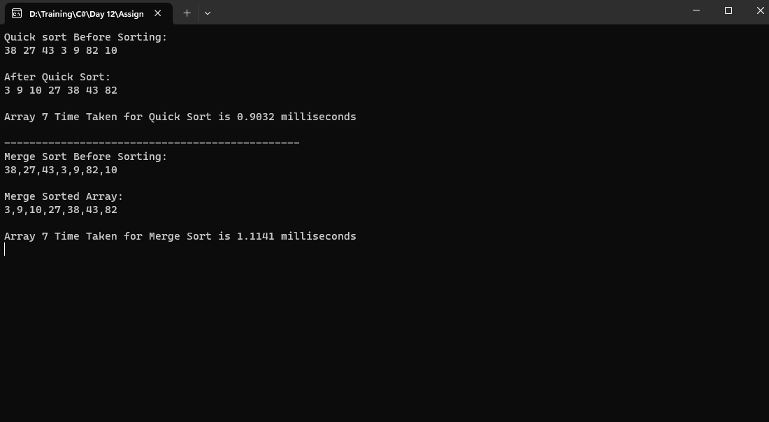

**Advantages of Quick Sort:**

1. Higher Efficiency.
2. Easy to implement.

**Disadvantages of Quick Sort:**

1. Worst Case Complexity.
2. Poor Pivot Selection.